Old School Surgery

August Bank Holiday – Important Dates

Tuesday 22 August 2017 – Last date for ordering repeat prescriptions required before the Bank Holiday for collection from the pharmacist.

Wednesday 23 August 2017 – Last date for ordering repeat prescriptions required before the Bank Holiday for collection from the Surgery.

Monday 28 August 2017 – The surgery is closed.

Tuesday 29 August 2017 – The surgery will re-open at 8:30 AM.

August 2017


PRACTICE NEWSLETTER

INSIDE THIS
issue:

August Bank Holiday
Weekend & Bank Holiday Prescription Requests
Staff Changes
Medication Requested by Hospital
Belfast Marathon
Impact Agewell Programme

Bank Holiday - On-line Prescription Requests
Please note prescriptions ordered from 5pm on Friday 25 August 2017 will not be processed until we re-open on Tuesday 29 August 2017. Unfortunately Prescriptions will not be available within the normal timeframe. We would be grateful if you could allow additional time before collecting your prescription from the surgery or nominated pharmacy. Many thanks.

Staff Changes
- Dr Kathryn Wilson has now left the Practice and will no longer be available for bookings.
- We welcomed our new Registrar, Dr Darrah, to the Practice at the beginning of August.
- We have a new Pharmacist at the Practice, Alexis Bradley, who will be assisting our GPs with medication requests. (Please see additional information below).
- Please be reminded that Dr Crothers will be retiring from the Practice at the end of the year. Dr Erin Johnston will be joining the Practice from January 2018.

Medication Requested by the Hospital
Our new Pharmacist, Alexis Bradley, will be assisting the Practice with all medication that is requested by letter from the hospital.
Please be advised that your medication will be ready no earlier than 4:30pm the following day after you provide us with your hospital letter. This is a necessary measure to ensure safe prescribing.

Success at Belfast Marathon!

Congratulations to all our amazing doctors who completed the Belfast Marathon on 1 May 2017.

Dr's Kernohan, White, Bell & Alexander participated in the relay event & Dr Bradley completed the whole 26 miles! This year the doctors raised donations in aid to the Children's Heartbeat Trust. This is a local charity who work closely with the Clark Clinic at the RBHSC to ensure children with heart disease and their families receive the best care, treatment and support possible. It is a charity solely funded by the generosity of the public.

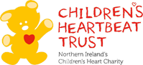
If you would like further information regarding the Children's Heartbeat Trust please visit www.childrensheartbeattrust.org.

Can we Help You? Why not take part in our Impact Agewell Programme!
,
What is the Impact Agewell Programme?
This is a 3 year pilot programme with the aim of improving the quality of life for older people by providing them with person centred services and support to improve and meet the health and wellbeing outcomes that matter most to them.
How do I know if I’m eligible to take part? Please speak to a GP or staff member if you:
- Are aged 70 and over
- Have a long term health condition
- Live alone or with another older person aged 60 years and over in your own home or sheltered housing
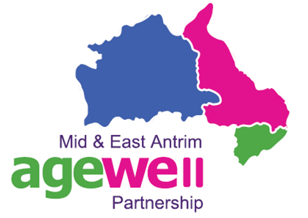
- Reside within the Mid and East Antrim area.

Why take part?

- I am unsure who to turn to for help
- I want to learn how to improve and manage my health
- I am unsure what my medication is for or how to use it
- I feel my age means I am not a priority
- I would enjoy being connected with members of my community

We look forward to hearing from you.

